UNITED STATES
SECURITIES AND EXCHANGE COMMISSION
WASHINGTON, DC 20549

FORM 8-K

CURRENT REPORT
Pursuant to Section 13 or 15(d)
of the Securities Exchange Act of 1934

Date of report (Date of earliest event reported): July 10, 2026

Beneficient
(Exact Name of Registrant as Specified in Charter)

Nevada |  | 001-41715 |  | 72-1573705
(State or Other Jurisdiction  of Incorporation) |  | (Commission  File Number) |  | (I.R.S. Employer  Identification No.)

325 North St. Paul Street, Suite 4850
Dallas, Texas 75201
(Address of Principal Executive Offices, and Zip Code)

(214) 445-4700
Registrant’s Telephone Number, Including Area Code

N/A
(Former Name or Former Address, if Changed Since Last Report)

Check the appropriate box below if the Form 8-K filing is intended to simultaneously satisfy the filing obligation of the registrant under any of the following provisions (see General Instruction A.2. below):

☐ | Written communication pursuant to Rule 425 under the Securities Act (17 CFR 230.425)
☒ | Soliciting material pursuant to Rule 14a-12 under the Exchange Act (17 CFR 240.14a-12)
☐ | Pre-commencement communications pursuant to Rule 14d-2(b) under the Exchange Act (17 CFR 240.14d-2(b))
☐ | Pre-commencement communications pursuant to Rule 13e-4(c) under the Exchange Act (17 CFR 240.13e-4(c))

Securities registered pursuant to Section 12(b) of the Act:

Title of each class |  | Trading Symbol(s) |  | Name of each exchange on which registered
Shares of Class A common stock, par value $0.001 per share |  | BENF |  | Nasdaq Stock Market LLC
Warrants, each whole warrant exercisable for one share of Class A common stock, par value $0.001 per share, and one share of Series A convertible preferred stock, par value $0.001 per share |  | BENFW |  | Nasdaq Stock Market LLC

Indicate by check mark whether the registrant is an emerging growth company as defined in Rule 405 of the Securities Act of 1933 (17 CFR §230.405 of this chapter) or Rule 12b-2 of the Securities Exchange Act of 1934 (17 CFR §240.12b-2 of this chapter).

Emerging growth company ☒

If an emerging growth company, indicate by check mark if the registrant has elected not to use the extended transition period for complying with any new or revised financial accounting standards provided pursuant to Section 13(a) of the Exchange Act. ☐

Item 3.02 Unregistered Sales of Equity Securities.

On July 10, 2026, Beneficient, a Nevada corporation (the “Company”), through one of its subsidiaries, funded the closing of a primary capital transaction pursuant to definitive agreements entered into on July 8, 2026 with a customer with respect to a limited partner interest in an investment fund with a net asset value of $7.44 million (the “Transaction”). Pursuant to the Transaction, the Company’s customized trust vehicles acquired a limited partner interest, and in exchange for such interests, the customer received 744,455 shares of the Company’s Series B-11 Resettable Convertible Preferred Stock, par value $0.001 per share (the “Series B-11 Preferred Stock”), with such Series B-11 Preferred Stock being convertible into shares of the Company’s Class A Common Stock, par value $0.001 per share (the “Class A Common Stock”).

The issuance of the Series B-11 Preferred Stock pursuant to the Transaction was not registered under the Securities Act of 1933, as amended (the “Securities Act”), and was issued in reliance upon the exemption provided in Section 4(a)(2) of the Securities Act and Regulation D promulgated thereunder.

The Series B-11 Preferred Stock is convertible into Class A Common Stock initially at a conversion price of $3.6514 per share (the “B-11 Conversion Price”). The B-11 Conversion Price is subject to reset from time to time and a floor price of $1.8257 per share. A maximum of 4,077,642 shares of Class A Common Stock may be issued upon conversion of the Series B-11 Preferred Stock. The information in Item 5.03 concerning the material terms of the Series B-11 Preferred Stock is incorporated by reference herein.

Item 3.03 Material Modifications to Rights of Security Holders.

The disclosure required by this Item 3.03 is included in Item 5.03 of this Current Report on Form 8-K and is incorporated herein by reference.

Item 5.03 Amendments to Articles of Incorporation or Bylaws; Change in Fiscal Year.

Series B-11 Preferred Stock

On July 10, 2026, the Company filed a certificate of designation (the “B-11 Certificate of Designation”) with the Secretary of State of Nevada, effective as of the time of filing, designating the rights, preferences, privileges and restrictions of the shares of the Series B-11 Preferred Stock. The material terms of the Series B-11 Preferred Stock are described below. The total number of authorized shares of the Series B-11 Preferred Stock is 744,455 shares.

Optional Conversion

Each share of Series B-11 Preferred Stock is convertible, at the option of the holder thereof upon two business days’ written notice to the Company, into a number of shares of Class A Common Stock that is equal to $10.00 divided by the B-11 Conversion Price in effect as of the date of such notice (the “B-11 Conversion Rate”). The B-11 Conversion Price shall be subject to reset on each date (each such date, a “B-11 Reset Date”) that is the last day of each month following the date of issuance of the Series B-11 Preferred Stock (the “B-11 Original Issue Date”). On each B-11 Reset Date, the B-11 Conversion Price shall be increased or decreased to the five day trailing volume weighted average price of the Class A Common Stock on the Nasdaq Capital Market or such other national securities exchange on which the Class A Common Stock is listed for trading as of the applicable B-11 Reset Date as reported by Bloomberg Financial Markets or an equivalent reporting service as determined by the Company (the “Prevailing Market Price”), provided that in no event shall the reset B-11 Conversion Price be (a) less than 50% of the initial B-11 Conversion Price or (b) higher than the initial B-11 Conversion Price, in each case subject to adjustments for stock dividends, splits or combinations, reorganizations, recapitalizations or similar transactions. As further described in the B-11 Certificate of Designation, the Company will not issue any shares of Class A Common Stock upon conversion of any Series B-11 Preferred Stock if the issuance of such shares of Class A Common Stock would exceed the Exchange Cap (as defined below), except that such limitation shall not apply in the event that the Company obtains the approval of its stockholders as required by the applicable rules and regulations of The Nasdaq Stock Market, LLC (“Nasdaq”) for issuances of shares of Class A Common Stock in excess of the Exchange Cap.

Mandatory Conversion

Each outstanding share of Series B-11 Preferred Stock will automatically convert into a number of shares of Class A Common Stock (the “B-11 Mandatory Conversion”) as is determined by the B-11 Conversion Rate then in effect on the date (the “B-11 Mandatory Conversion Date”) that is the earliest to occur of: (a) the last day of the month in which the fifth anniversary of the B-11 Original Issue Date occurs, if either the Company has filed all annual reports on Form 10-K and quarterly reports on Form 10-Q that are then required to have been filed in the preceding twelve months with the United States Securities and Exchange Commission (the “SEC”) under the Securities Exchange Act of 1934, as amended (the “Exchange Act”), or a resale registration statement with respect to the shares of Class A Common Stock underlying the Series B-11 Preferred Stock (the “B-11 Resale Registration Statement”) has become effective and is in full force and effect at the time of such B-11 Mandatory Conversion and (b) if the conditions of clause (a) are not met on the date that is the last day of the month in which the fifth anniversary of the B-11 Original Issue Date occurs, the first date thereafter on which any shares of Series B-11 Preferred Stock may be resold pursuant to Rule 144 under the Securities Act, or the B-11 Resale Registration Statement has become effective. Notwithstanding the foregoing, the Series B-11 Preferred Stock shall not convert into Class A Common Stock to the extent such conversion would cause a holder to exceed (i) 4.99% (the “B-11 Beneficial Ownership Limitation”) of the number of shares of the Class A Common Stock outstanding immediately after giving effect to the issuance of shares of Class A Common Stock issuable upon conversion of Series B-11 Preferred Stock held by the applicable holder or (ii) the aggregate number of shares of Class A Common Stock that the Company may issue upon conversion of the Series B-11 Preferred Stock without breaching the Company’s obligations under the rules and regulations of Nasdaq (the number of shares which may be issued without violating such rules and regulations, the “Exchange Cap”). To the extent a conversion would cause a holder to exceed the B-11 Beneficial Ownership Limitation or Exchange Cap, as applicable, the conversion of the portion of such conversion that would exceed the B-11 Beneficial Ownership Limitation or Exchange Cap, as applicable, shall be delayed until the first day the conversion of such portion would not cause the holder to exceed the B-11 Beneficial Ownership Limitation or, with respect to the Exchange Cap, when stockholder approval as required by the applicable rules and regulations of Nasdaq has been obtained. Further, to the extent any such share of Series B-11 Preferred Stock has not otherwise automatically converted into shares of Class A Common Stock, the B-11 Conversion Price for such shares shall be subject to additional resets on the terms described in the B-11 Certificate of Designation on the last date of each month.

Ranking

Series B-11 Preferred Stock will, with respect to dividend rights and rights upon liquidation, dissolution or winding up of the Company, rank: (a) junior with respect to the Company’s Series A Convertible Preferred Stock, par value $0.001 per share; (b) pari passu to the Class A Common Stock, Series B-1 Resettable Convertible Preferred Stock, par value $0.001 per share, Series B-2 Resettable Convertible Preferred Stock, par value $0.001 per share, Series B-3 Resettable Convertible Preferred Stock, par value $0.001 per share, Series B-4 Resettable Convertible Preferred Stock, par value $0.001 per share, Series B-5 Resettable Convertible Preferred Stock, par value $0.001 per share, Series B-6 Resettable Convertible Preferred Stock, par value $0.001 per share, Series B-7 Resettable Convertible Preferred Stock, par value $0.001 per share, Series B-8 Resettable Convertible Preferred Stock, par value $0.001 per share, Series B-9 Resettable Convertible Preferred Stock, par value $0.001 per share, and Series B-10 Resettable Convertible Preferred Stock, par value $0.001 per share; (c) senior, pari passu or junior with respect to any other series of preferred stock, as set forth in the Certificate of Designation with respect to such preferred stock; and (d) junior to all existing and future indebtedness of the Company.

Liquidation Preference

In the event of any liquidation or dissolution of the Company, the holders of Series B-11 Preferred Stock shall be entitled to receive, pro rata with the holders of the Company’s Class A Common Stock, and any other shares of preferred stock of the Company identified as “Designated Preferred Stock,” a per share amount equal to such amount per share as would have been payable had all shares of Series B-11 Preferred Stock been converted to Class A Common Stock pursuant to Section 8 of the B-11 Certificate of Designation (without giving effect to any ownership limitations therein) immediately prior to such liquidation or dissolution of the Company (the “Liquidation Preference”). The Series B-11 Preferred Stock shall be a series of Designated Preferred Stock.

Dividends

Dividends will be paid on the Series B-11 Preferred Stock on an as-converted basis when, as, and if paid on the Class A Common Stock.

Voting Rights

Except as required by law, the holders of Series B-11 Preferred Stock shall not be entitled to vote at any meeting of the stockholders for election of members of the Board of Directors of the Company or for any other purpose or otherwise to participate in any action taken by the Company or the stockholders thereof, or to receive notice of any meeting of stockholders.

The foregoing summary of the B-11 Certificate of Designation does not purport to be complete and is subject to, and qualified in its entirety by, such document, which is filed as Exhibit 3.1 to this Current Report on Form 8-K and is incorporated herein by reference.

Item 7.01 Regulation FD Disclosure.

On July 13, 2026, the Company issued a press release announcing the closing of the Transaction.

A copy of the press release is attached hereto as Exhibit 99.1 and is incorporated by reference herein.

The information in this Item 7.01 (including Exhibit 99.1) is being furnished pursuant to Item 7.01 and shall not be deemed to be “filed” for the purposes of Section 18 of the Exchange Act, or otherwise subject to liabilities of that section, nor shall it be deemed incorporated by reference in any filing under the Securities Act, except as expressly set forth in such filing.

Item 9.01 Financial Statements and Exhibits.

(d) Exhibits.

Exhibit No. |  | Description of Exhibit
3.1 |  | Certificate of Designation of Series B-11 Resettable Convertible Preferred Stock.
99.1 |  | Press Release issued by Beneficient on July 13, 2026.
104 |  | Cover Page Interactive Data File (formatted as Inline XBRL).

Cautionary Note Regarding Forward-Looking Statements

Except for the historical information contained herein, the matters set forth in this Current Report on Form 8-K are forward-looking statements within the meaning of the “safe harbor” provisions of the Private Securities Litigation Reform Act of 1995. The forward-looking statements contained in this Current Report include, without limitation, statements related to the Transaction and the issuance of Class A Common Stock upon conversion of the Series B-11 Preferred Stock. These and other forward-looking statements are based on management’s current views and assumptions and involve risks and uncertainties that could significantly affect expected results. Important factors that could cause actual results to differ materially from those expressed in the forward-looking statements include, among other things, the risks, uncertainties, and factors set forth under “Risk Factors” in the Company’s most recent Annual Report on Form 10-K and its subsequently filed Quarterly Reports on Form 10-Q. The Company assumes no obligation to update forward-looking statements to reflect actual results, subsequent events, or circumstances or other changes affecting such statements except to the extent required by applicable law.

Forward-looking statements speak only as of the date they are made. Readers are cautioned not to put undue reliance on forward-looking statements, and, except as required by law, the Company assumes no obligation and does not intend to update or revise these forward-looking statements, whether as a result of new information, future events, or otherwise.

Important Information and Where You Can Find It

This Current Report on Form 8-K may be deemed to be solicitation material in respect of a vote of stockholders to approve the issuance of Class A Common Stock upon conversion of the Series B-11 Preferred Stock. In connection with the requisite stockholder approval, the Company will file with the SEC a preliminary proxy statement and a definitive proxy statement, which will be sent to the stockholders of the Company, seeking such approvals related to the issuance of Class A Common Stock upon conversion of the Series B-11 Preferred Stock.

INVESTORS AND SECURITY HOLDERS OF THE COMPANY AND THEIR RESPECTIVE AFFILIATES ARE URGED TO READ, WHEN AVAILABLE, THE PROXY STATEMENT AND ANY OTHER RELEVANT DOCUMENTS FILED OR TO BE FILED WITH THE SEC IN CONNECTION WITH THE TRANSACTION DESCRIBED HEREIN, AS WELL AS ANY AMENDMENTS OR SUPPLEMENTS TO THOSE DOCUMENTS, BECAUSE THEY WILL CONTAIN IMPORTANT INFORMATION ABOUT THE COMPANY AND THE TRANSACTION. Investors and security holders will be able to obtain a free copy of the proxy statement, as well as other relevant documents filed with the SEC containing information about the Company, without charge, at the SEC’s website (http://www.sec.gov). Copies of documents filed with the SEC by the Company can also be obtained, without charge, by directing a request to Investor Relations, Beneficient at 325 North St. Paul Street, Suite 4850, Dallas, Texas 75201 or via email at investors@beneficient.com.

Participants in the Solicitation of Proxies in Connection with the Transaction

The Company and certain of its directors, executive officers and employees may be deemed to be participants in the solicitation of proxies in respect of the requisite stockholder approvals under the rules of the SEC. Information regarding the Company’s directors and executive officers is available in its Annual Report on Form 10-K, which was filed with the SEC on June 30, 2026, and certain current reports on Form 8-K filed by the Company. Other information regarding the participants in the solicitation of proxies with respect to the transaction described herein and a description of their direct and indirect interests, by security holdings or otherwise, will be contained in the proxy statement and other relevant materials to be filed with the SEC. Free copies of these documents, when available, may be obtained as described in the preceding paragraph.

Not an Offer of Securities

The information in this Current Report on Form 8-K is for informational purposes only and shall not constitute, or form a part of, an offer to sell or the solicitation of an offer to sell or the solicitation of an offer to buy any securities. The securities that are the subject of the transaction described herein have not been registered under the Securities Act and may not be offered or sold in the United States absent registration or an applicable exemption from registration requirements.

SIGNATURES

Pursuant to the requirements of the Securities Exchange Act of 1934, as amended, the registrant has duly caused this report to be signed on its behalf by the undersigned hereunto duly authorized.

 | BENEFICIENT
 | By: | /s/ Gregory W. Ezell
 | Name: | Gregory W. Ezell
 | Title: | Chief Financial Officer
 | Dated: July 13, 2026

Exhibit 3.1

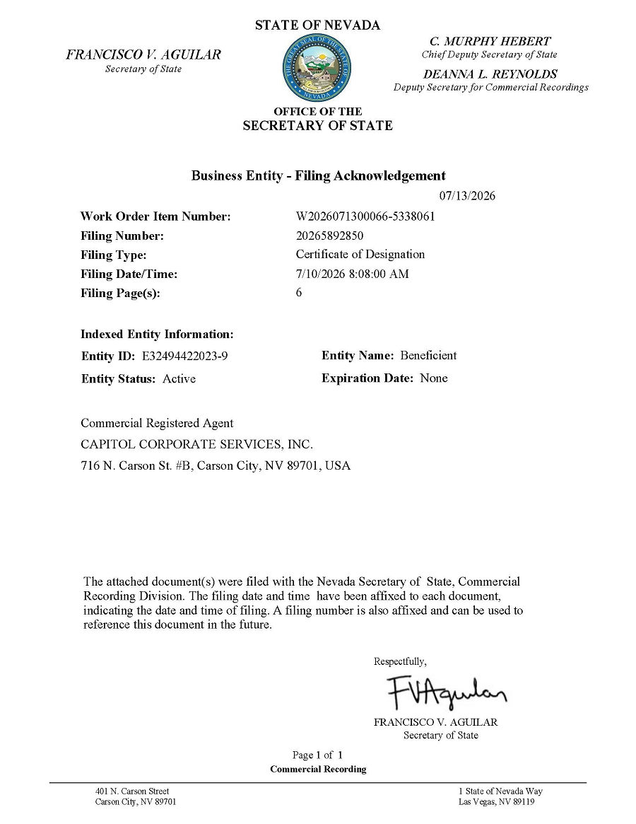

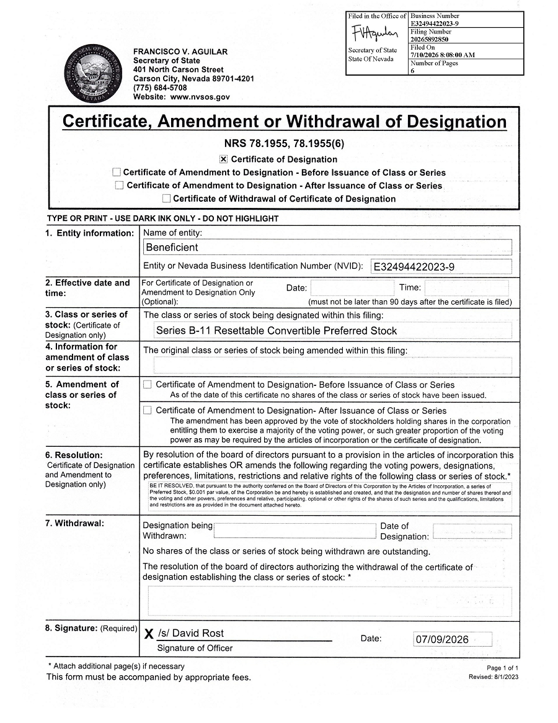





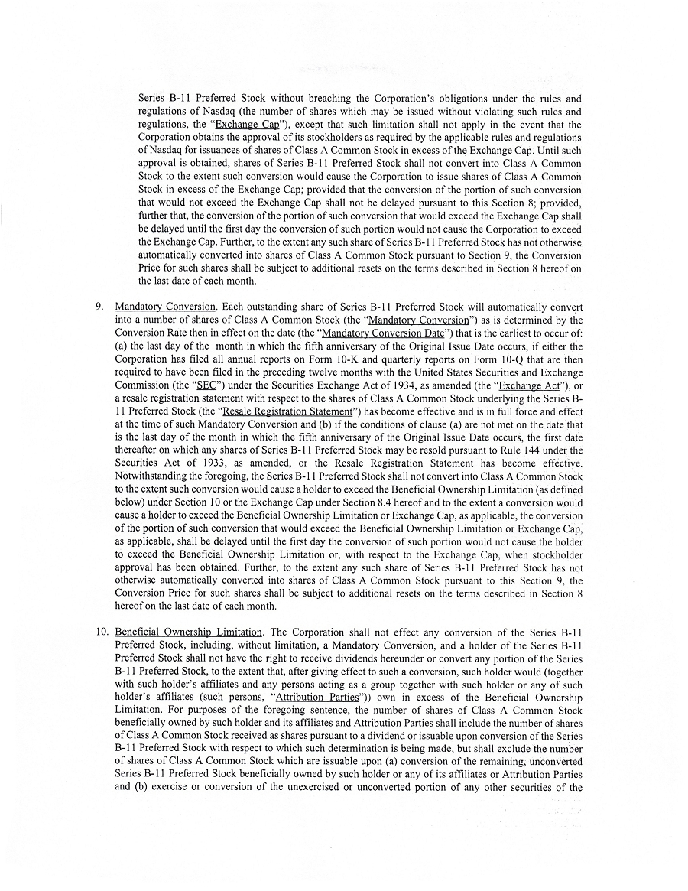





Exhibit 99.1

Beneficient Closes $7.44 Million GP Primary Capital Transaction

DALLAS, July 13, 2026 (GLOBE NEWSWIRE) — Beneficient (NASDAQ: BENF) (“Ben” or the “Company”), a technology-enabled platform providing exit opportunities and primary capital solutions and related trust and custody services to holders of alternative assets, today announced it has closed on the financing of a $7.44 million primary capital commitment in Quartus AI Fund II LP (the “Fund”), a fund managed by Quartus Capital Partners LLC (“Quartus”), a New York based investment firm investing in growth stage AI and technology ventures (the “Transaction”). Quartus is led by AI pioneers, technologists, and seasoned operators.

The Transaction reflects continued momentum for the Company’s GP Primary Commitment Program and further execution of its strategy to provide primary capital solutions to qualifying private investment funds, while marking Beneficient’s second GP primary capital transaction this year with an AI-focused fund managed by Quartus. As consideration for the Company’s interest in the Fund, the Fund received approximately $7.44 million in stated value of shares of the Company’s Resettable Convertible Preferred Stock (the “Preferred Stock”), which is convertible at the election of the holder into shares of the Company’s Class A common stock, subject to the terms and conditions of the Transaction documents. The Company’s commitment is structured to scale with the Fund’s total capital commitments, up to $26.25 million if the Fund achieves its target capital commitments of $150 million.

The Transaction is expected to increase the collateral for the Company’s ExAlt loan portfolio by approximately $7.44 million of interests in alternative assets and add approximately $7.44 million of tangible book value attributable to the Company’s stockholders. Fiscal year to date, the Company’s GP primary capital transactions have contributed approximately $17.2 million of aggregate tangible book value attributable to the Company’s stockholders.

“We are pleased to expand our relationship with Quartus by closing this Transaction with a second AI-focused fund that Quartus manages,” said James Silk, Beneficient CEO. “Artificial intelligence continues to be one of the most dynamic and actively expanding areas of the global technology market, and we are excited that our GP Primary Commitment Program provides Beneficient with a pathway to participate in that growth through exposure to differentiated AI-focused private investment funds. The Company will continue to pursue transactions that we believe can drive shareholder value, strengthen the collateral backing our ExAlt loan portfolio, and expand Beneficient’s exposure to high-growth areas of the private markets.”

The Fund is expected to target growth stage AI-based and AI-enabled companies that generate at least $5 million of commercial revenue and have meaningful growth potential. Quartus expects the Fund to pursue a diversified portfolio across high-growth sectors, including HealthTech, EdTech, Physical AI, such as autonomous vehicles, robotics and other AI systems that interact with the physical world, World Models, LegalTech, Logistics, and Safety and Security. Quartus believes the Fund’s focus on more commercially mature companies, together with its diversified sector strategy in a rapidly expanding market, may provide the potential for faster growth and reduced downside risk.

Beneficient’s GP Primary Commitment Program is focused on providing primary capital solutions and financing anchor commitments to general partners during their fundraising efforts while immediately deploying capital into our equity. Through the program, Beneficient seeks to help satisfy the up to $330 billion of potential demand for primary commitments to meet fundraising needs.

Reconciliation of Non-GAAP Financial Measures

The following tables reconcile these non-GAAP financial measures to the most comparable GAAP financial measures as of March 31, 2026, on an actual basis and pro forma assuming the Transaction occurred on March 31, 2026, and pro forma giving effect to the Company’s GP Primary capital transactions completed during this fiscal year.

(dollars in thousands) |  | Actual |  |  |  | Pro forma – Transaction |  |  |  | Pro forma – YTD transactions
Tangible Book Value
Total equity (deficit) |  |  | (189,286 | ) |  |  | (181,842 | ) |  |  | (172,072 | )
Less: Goodwill |  |  | (9,914 | ) |  |  | (9,914 | ) |  |  | (9,914 | )
Plus: Total temporary equity |  |  | 90,526 |  |  |  | 90,526 |  |  |  | 90,526
Tangible book value |  |  | (108,674 | ) |  |  | (101,230 | ) |  |  | (91,460 | )

 |  | Actual |  |  |  | Pro forma – Transaction |  |  |  | Pro forma – YTD transactions
Tangible book value attributable to public company stockholders
Tangible book value |  |  | (108,674 | ) |  |  | (101,230 | ) |  |  | (91,460 | )
Less: Tangible book value attributable to Beneficient Holdings noncontrolling interest holders |  |  | (108,674 | ) |  |  | (108,674 | ) |  |  | (108,674 | )
Tangible book value attributable to Ben’s public company stockholders |  |  | — |  |  |  | 7,444 |  |  |  | 17,214
Market Capitalization of Ben’s Class A and Class B common stock as of July 10, 2026 (1) |  | $ | 50,646

(1) | Based upon the closing price of the Class A common stock as reported by Nasdaq as of market close on July 10, 2026.

About Beneficient

Beneficient (Nasdaq: BENF) – Ben, for short – is on a mission to democratize the global alternative asset investment market by providing traditionally underserved investors − mid-to-high net worth individuals, small-to-midsized institutions and General Partners seeking exit options, anchor commitments and preferred liquidity services for their funds − with solutions that could help them unlock the value in their alternative assets.

Its subsidiary, Beneficient Fiduciary Financial, L.L.C., received its charter under the State of Kansas’ Technology-Enabled Fiduciary Financial Institution (TEFFI) Act and is subject to regulatory oversight by the Office of the State Bank Commissioner.

For more information, visit www.trustben.com or follow us on LinkedIn.

Contacts

Matt Kreps: 214-597-8200, mkreps@darrowir.com

Michael Wetherington: 214-284-1199, mwetherington@darrowir.com

Investor Relations: investors@beneficient.com

Important Information and Where You Can Find It

This press release may be deemed to be solicitation material in respect of a vote of stockholders to approve the issuance of the Company’s Class A common stock upon conversion of the Preferred Stock. In connection with the requisite stockholder approval, Ben will file with the Securities and Exchange Commission (the “SEC”) a preliminary proxy statement and a definitive proxy statement, which will be sent to the stockholders of Ben, seeking such approvals related to the Transaction.

INVESTORS AND SECURITY HOLDERS OF BEN AND THEIR RESPECTIVE AFFILIATES ARE URGED TO READ, WHEN AVAILABLE, THE PROXY STATEMENT AND ANY OTHER RELEVANT DOCUMENTS FILED OR TO BE FILED WITH THE SEC IN CONNECTION WITH THE TRANSACTION, AS WELL AS ANY AMENDMENTS OR SUPPLEMENTS TO THOSE DOCUMENTS, BECAUSE THEY WILL CONTAIN IMPORTANT INFORMATION ABOUT BEN AND THE TRANSACTION. Investors and security holders will be able to obtain a free copy of the proxy statement, as well as other relevant documents filed with the SEC containing information about Ben, without charge, at the SEC’s website (http://www.sec.gov). Copies of documents filed with the SEC by Ben can also be obtained, without charge, by directing a request to Investor Relations, Beneficient, 325 North St. Paul Street, Suite 4850, Dallas, Texas 75201, or email investors@beneficient.com.

Participants in the Solicitation of Proxies in Connection with Transaction

Ben and certain of its directors, executive officers and employees may be deemed to be participants in the solicitation of proxies in respect of the requisite stockholder approvals under the rules of the SEC. Information regarding Ben’s directors and executive officers is available in its annual report on Form 10-K for the fiscal year ended March 31, 2026, which was filed with the SEC on June 30, 2026 and certain current reports on Form 8-K filed by Ben. Other information regarding the participants in the solicitation of proxies with respect to the Transaction and a description of their direct and indirect interests, by security holdings or otherwise, will be contained in the proxy statement and other relevant materials to be filed with the SEC. Free copies of these documents, when available, may be obtained as described in the preceding paragraph.

Not an Offer of Securities

The information in this communication is for informational purposes only and shall not constitute, or form a part of, an offer to sell or the solicitation of an offer to sell or the solicitation of an offer to buy any securities. The securities that are the subject of the Transaction have not been registered under the Securities Act of 1933, as amended, and may not be offered or sold in the United States absent registration or an applicable exemption from registration requirements.

Forward Looking Statements

Except for the historical information contained herein, the matters set forth in this press release are forward-looking statements within the meaning of the “safe harbor” provisions of the Private Securities Litigation Reform Act of 1995. Forward-looking statements include, but are not limited to, statements regarding the Transaction, the expected benefits of the Transaction, the expected increase in collateral for the Company’s ExAlt loan portfolio, the expected addition to tangible book value attributable to the Company’s stockholders, the Fund’s investment strategy and potential performance, growth, and investment risks. The words “anticipate,” “believe,” “continue,” “could,” “estimate,” “expect,” “intends,” “may,” “might,” “plan,” “possible,” “potential,” “predict,” “project,” “should,” “would” and similar expressions may identify forward-looking statements, but the absence of these words does not mean that a statement is not forward-looking. Forward-looking statements are based on our management’s beliefs, as well as assumptions made by, and information currently available to, them. Because such statements are based on expectations as to future financial and operating results and are not statements of fact, actual results may differ materially from those projected.

Important factors that could cause actual results to differ materially from those expressed in the forward-looking statements include, among others: the ultimate outcome of the Transaction, and the risks, uncertainties, and factors set forth under “Risk Factors” in the Company’s most recent Annual Report on Form 10-K and its subsequently filed Quarterly Reports on Form 10-Q. Forward-looking statements speak only as of the date they are made. The Company assumes no obligation to update forward-looking statements to reflect actual results, subsequent events, or circumstances or other changes affecting such statements except to the extent required by applicable law.

Forward-looking statements speak only as of the date they are made. Readers are cautioned not to put undue reliance on forward-looking statements, and, except as required by law, the Company assumes no obligation and does not intend to update or revise these forward-looking statements, whether as a result of new information, future events, or otherwise.

